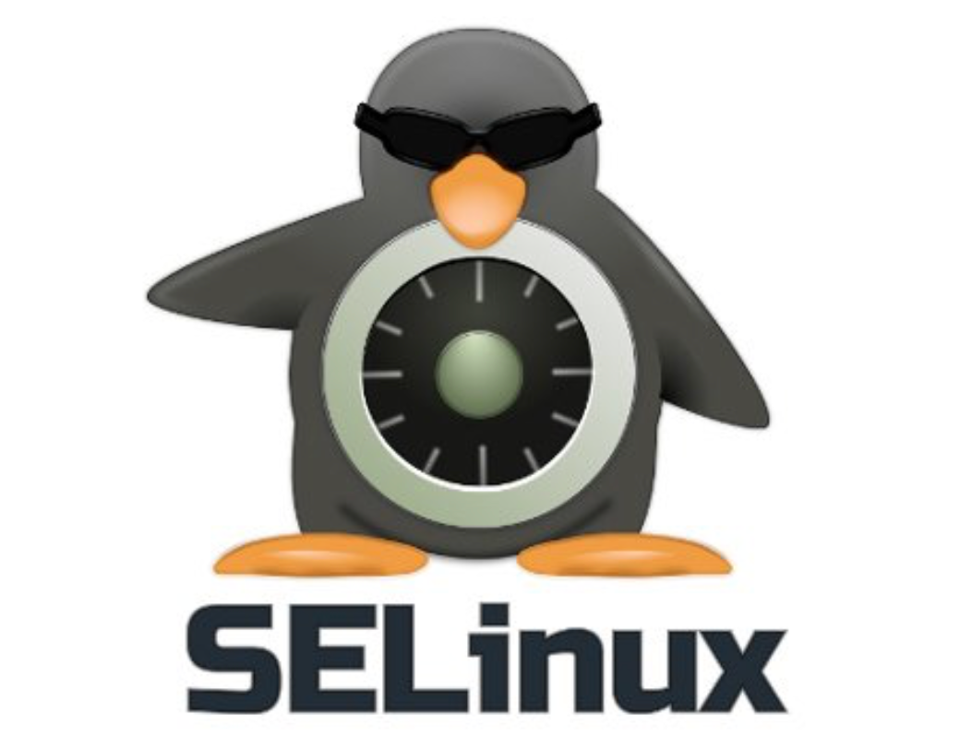
Selinux Tutorial (Basics)
https://linuxtechlab.com/beginners-guide-to-selinux/

NOTE: this tutorial is being done on a fresh install of Centos8 Workstation – Selinux (the kernel module) is installed and ENFORCING by default (we’ll learn what that means momentarily).

What IS SELinux ?

It’s “Security Enhanced Linux” and it offers advanced access control and was designed by the NSA in 2015 (so, post-RHEL7 even. Very up to date).
It has THREE different operating modes:
1. Enforcing (denies access based on policy rules)
2. Permissive (logs privacy violations but allows access anyway)
3. Disabled (totally disabled)

The config file (as all system config files should be) is under “/etc/” and is in /etc/selinux/config

Setting and Changing the SELinux operating modes:

To see which operating mode you’re in as any user you can run:
getenfroce
Which will return something like Enforcing or Permissive

To change the selinux operating mode it depends on what mode you want to set it to.

To set the mode to ENFORCING it’s:
setenforce 0
To set the mode to PERMISSIVE it’s:
setenforce 1

To completely disable, however, you will have to edit the config file!

vi /etc/selinux/config

And then we’ll need to change the SELINUX field to read:
SELINUX=disabled

First Time Configuring SELinux (Autolabeling):

Every process and file is LABELED in SELinux. The first time you configure it, you’ll need to apply these labels. This is done by creating a hidden file in the root directory:

First set the mode to permissive (see above).
Then touch the following file so that it’s noticed by SELinux on reboot when it’s loaded:

touch /.autorelabel
After a reboot SELinux will detect the file and start lableling all processes/files as it comes up. This is normal. After this you can set your operating mode to enforcing.
Rebooting now…. And back! During startup I saw it labeling files and processes.

And now that everything has been labeled and we’ve booted into permissive mode we can go back and set our machine to ENFORCING mode:

setenforce 1

[mike@mike-centos8 ~]$ sudo setenforce 1
[mike@mike-centos8 ~]$ sudo getenforce
Enforcing

Great and we’re good to go.

The log file for SELinux:

The log file is in “/var/log/audit/audit.log” - use some good ole’-fashioned grep.

Setting up Selinux Policy:

Selinux Policy are a set of rules that guides Selinux security engine. Policies are a set of rules for an environment. Let’s allow access to some of our denied services.

Selinux Booleans:

Booleans let us make changes to a part of a policy at runtime without needing to have knowledge of policy writing. This allows easy changes without having to reload or recompile SELinux Policy.

This is better demonstrated by using the semanage

Let’s take a look at what we have:

SELinux boolean State, Default Description

abrt_anon_write (off , off) Allow abrt to anon write

So the boolean is the name of the policy, we see the current state and default state, and we have a brief written description of what it does.

LET’S MODIFY A BOOLEAN:

ftp is the standard file transfer protocol. Let’s look to see what Selinux security policies are in place for it:

semanage boolean -l | grep ftp
We see a lot of ftp permissions… one of them is:

tftp_home_dir (off , off) Allow tftp to home dir

Our ftp can’t write to our home dir! Well that seems a little strange. I’d like to enable that. Thankfully, it’s very easy:

setsebool tftp_home_dir on

And now we’re able to write to our home dir with ftp!

Labeling and Context:

This is the most-common way for implementing Selinuxpolicy onto our servers. Every file, folder, process, and port has an SELinux Context as a label.

For files and folders you can view with “ls -Z”
For running processes ps -auxZ
For ports netstat -anpZ

(if you get what’s going on, the “-Z” switch..)

Creating Local Policies:

There might come a time where denials show up in audit.log and you need to make your own custom rules.

Audit2why and Audit2allow

What’s cool about the logging from Selinux is that the log lines themselves can feed into commands. Audit2why can feed in log lines of denied access to explain WHY something was unable to run.

grep <your thing> /var/log/audit.log | audit2why # figure out how
grep <your thing> /var/log/audit.log | audit2allow -M my_new_policy # make new policy

And voila ! A new policy is allowed. All that has to be done to enable it is:

semodule -l http_polixy.pp

And our local policies are loaded and we are no longer getting denied.

